
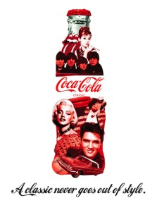
ADVERTISING
TECHNIQUES
Step 1
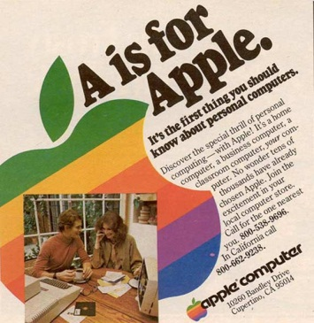
Advertising can affect consumer behaviors and choices as well as society and culture. Marketers use a variety of techniques and
strategies to spread their message to consumers and make
it stand out in the crowd. Some of these techniques are
obvious while others require more thought. Your goal will
be to either create or catalogue some of these ads
used to sell products and promote consumerism.

Choose whether you’d rather create your own advertisement or if you want to create a catalogue of existing advertisements.
Creating your ad will require more creativity but less written work. This also may take longer to create a polished product. You may work in groups of up to 4 for video ads. Speak to Mr. McRae about working in groups on print ads.
Creating a catalogue will require less creativity but more written work. You will also be expected to choose advertisements that have not already been discussed. This will be done individually.
Step 2

Pick up your assignment sheet and from the front and GET STARTED! You will have 2 hrs in class to work on this.

CREATE YOUR OWN ADVERTISMENT
You will create an advertisement in one of the following forms:
- Print (poster sized in groups, single paper for individual)
- Radio (create an mp3 of your ad)
- Video (using either the cameras in school or your own)
Step 1


Choose a product to advertise. This product can already
exist or you can make it up. Just remember that it has to
be appropriate for school! And you should be able to show
it somewhere in your ad.
Step 2


Choose a marketing technique that we discussed in class to
sell your product. Your choice should be clear in the ad and
no additional explanation should be required to identify it.
Different products might work better with different techniques.
Step 3

Now it’s time to create your advertisement using the following criteria:
Is it clear what product is being sold (/5)
Is a marketing technique used and applied correctly (/10)
Does the ad reflect or use principles of Consumerism (/10)

Catalogue advertisements
You will create a catalogue (either physical or digital) of advertisements that display the variety of techniques used by marketers to promote products.
Step 1

Choose a format to present your work in. Physical
catalogues will require all ads to be printed. Digital
catalogues can include video ads (ask Mr. McRae
how to embed YouTube videos into your presentations)
Step 2

Find an advertisement for EACH of the SIX techniques we
discussed in class. Each ad will be accompanied by a
brief description of how it uses the technique and
whether or not you think it is effective in doing so.

Step 3
When you have all SIX advertisements and descriptions you will write a brief response about ONE of the ads and how it reflects the principles of consumerism (be specific and use examples from the ad!)
Description of technique applied (/2) X 6
Is the ad effective or not (/1) X 6
Consumerism response (/7)

CONNECTION TO HEALTH
Advertising often spreads many of the ideas we have about society and ourselves. Whether or not these ideas are TRUE is less important than the fact we see them everywhere.
Step 1

Identify one stereotype that you would like to address
Step 2

Find an advertisement that spreads this idea to consumers. Explain.
Step 3

Find or create a counter advertisement that better reflects the real world or how you think the real world SHOULD work.


